Changes to SorpPropLib:

The input equation parameters, equation names and literature citings are no longer hardcoded. All of these values can be read in by using CSV files with a known format or by JSON files in the SorpPropLib format.

The CSV format is as follows:

Encoding: The CSV file must be UTF8 encoded. This can be done using Notepad by opening the file and saving it as UTF8.

Header row: first three columns are skipped,

the last column is the literature citing

the remaining columns are the parameter names.

NOTE: These parameter names must match the parameter names (lower case)

hardcoded in the equation header files.

Some do not presently match.

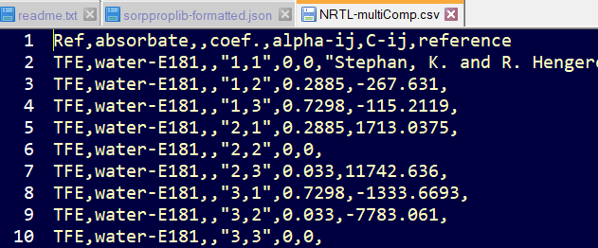Here is the first few lines of the NRTL-multicomp CSV file. Notice that I added an empty third column to conform to the expected format.

Also notice that the heading names do not match the NRTL equation parameter names. I was going to try and guess but I didn't know enough of them so you should check these.

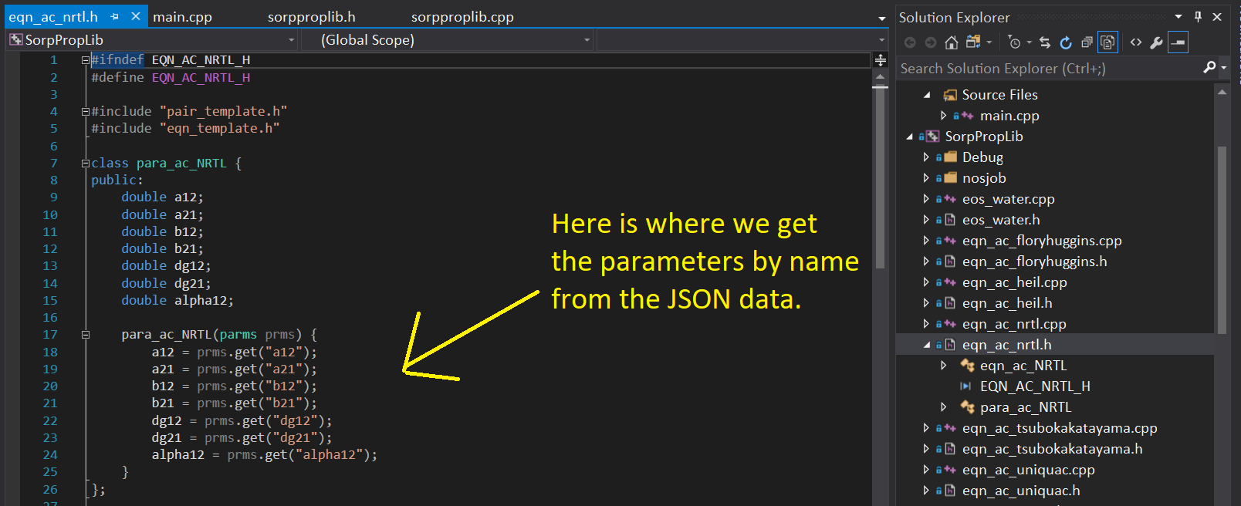

SorpPropBatch has optional provisions to check the data before writing and after reading the json. This is currently turned on for the write and turned off on the read. This output looks like:

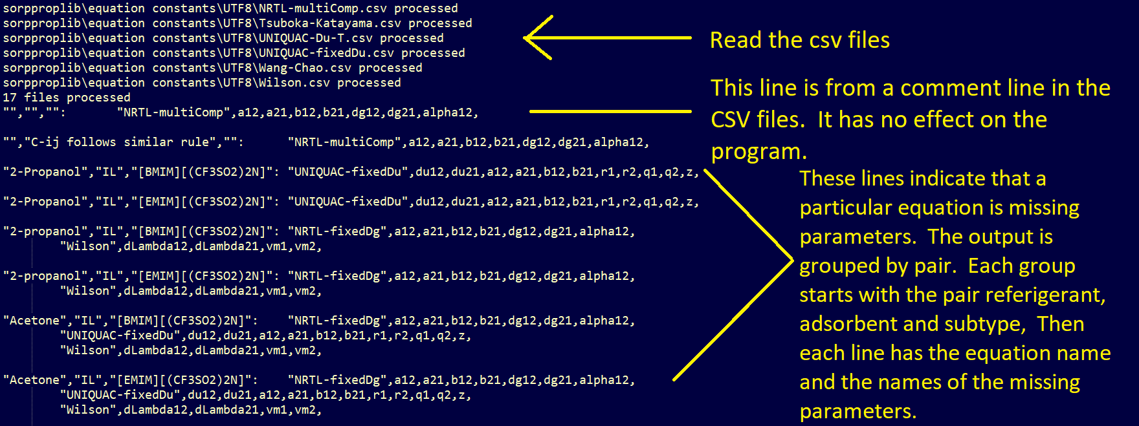

The parameter checking code is just below where we read the parameters from the JSON. Here you can add more checking like range checks, etc,

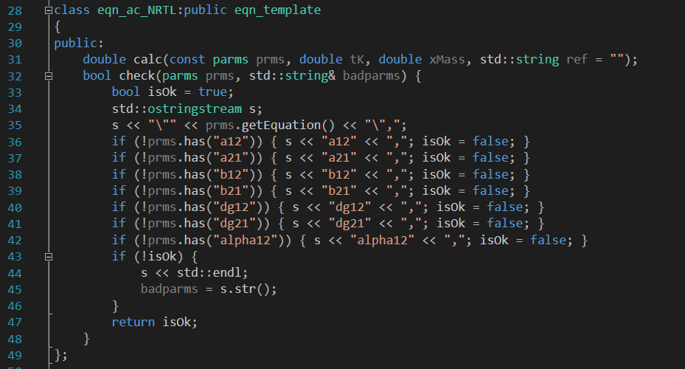

The JSON format is an internal object format and will be written on a single line for compactness.

You can use JSONLint to check and format the JSON: https://jsonlint.com/

The formatted JSON looks like:

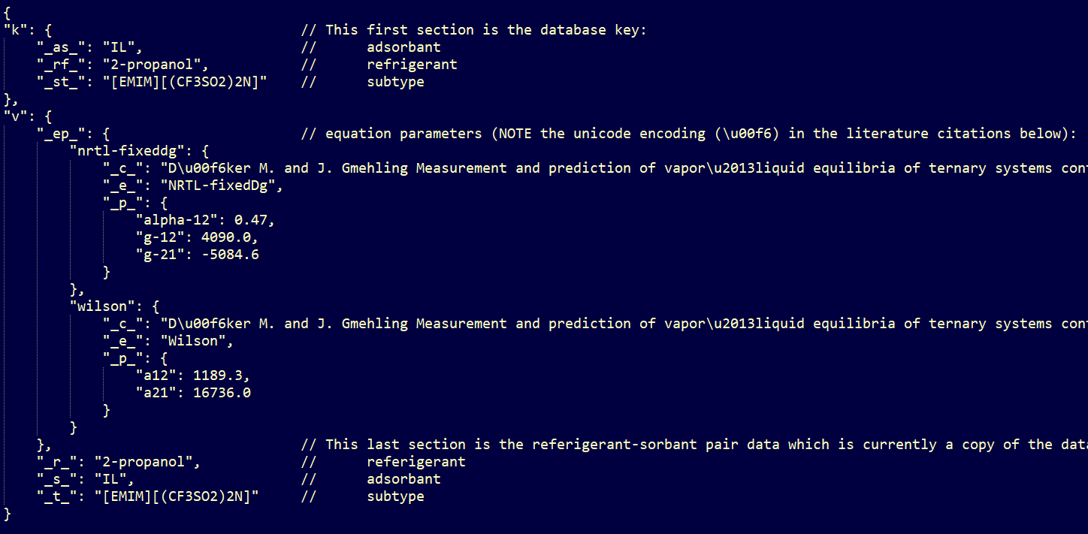

You can also edit the JSON if you prefer. It has to also be saved as UTF8.

SorpPropBatch can take 2 or 3 parameters. The first is the input. If this is a folder then SorpPropBatch will read all of the CSV files in that folder and write the JSON file. If the first parameter is a file, then it is assumed to be a tK, xMas input file. This parameter defaults to input,txt

The second parameter is the output text file and is only used for calculation output. This defaults to output.txt.

The third parameter is the name of the JSON file. This parameter defaults to SorpPropLib.json.